JOB DESCRIPTION
Job Title: | Staff Nurse
Department: | Clinical Nursing Team
Post Holder: | tbc
Grade: | Band 5
Reports to: | Service Lead
Accountable to: | Clinical Nurse Director

Organisation Chart:
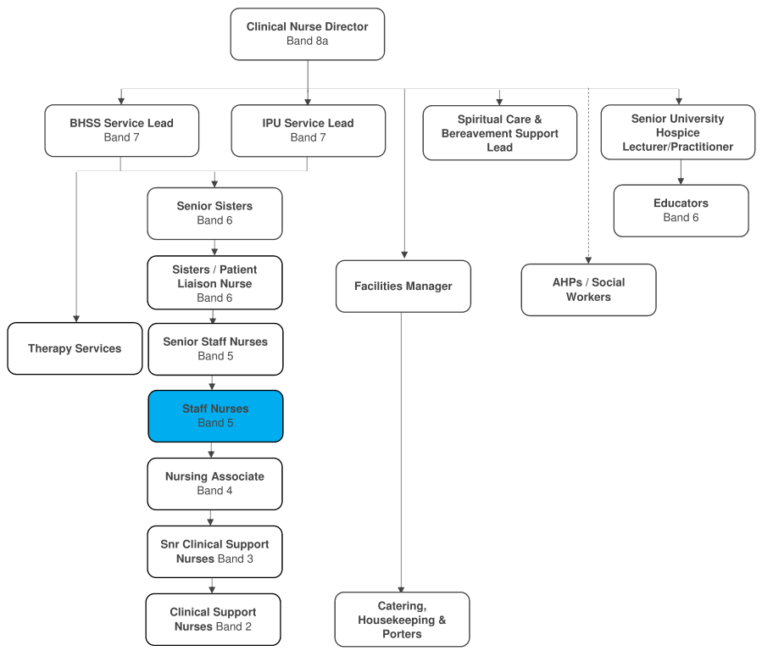
Job Purpose: | To work with others to ensure the highest standards of nursing and clinical care to patients and carers.  To advise and support staff, demonstrate competence in the speciality and broaden remit in line with current evidence based knowledge and training.

Key Working Relationships: | Clinical Nurse Director  Service Leads  Senior Sisters  Sisters  Senior Staff Nurses  Medical team  Members of the MDT  Housekeepers  Catering team  Porters
The duties and responsibilities of this post have been assessed as levels of competence required and reflect the skill and knowledge needed to satisfactorily perform the duties of the post.
Role Responsibilities:
Key Objectives
- Promote and maintain the philosophy of the hospice.
- Make decisions based upon knowledge and experience and be accountable for those decisions in the absence of the senior members of staff.
- Work closely with other disciplines and deputise for the Senior Staff Nurse.
- Promote and maintain high quality patient care by acting as a role model for more junior staff.
- Deliver Specialist Palliative Care to patients / families.
- Manage human resources and equipment.
- Ensure all staff work in accordance with Bolton Hospice policies, procedures and protocols.
- Ensure standards are maintained at all times.
Professional / Clinical Practice
- Work in accordance with the Nursing & Midwifery Council Code of Conduct.
- Provide clinical leadership and act as a role model in the delivery of high quality patient care.
- Demonstrate skills in the practice of palliative care.
- Promote the contribution of nursing within the multi-disciplinary team.
- Deputise in absence of the Senior Staff Nurses.
- Maintain and develop evidence based holistic care.
- Ensure accurate record keeping.
- Take on active role in clinical practice.
- Help create an environment which reflects the Hospice’s philosophy and its specialist palliative care approach.
- Undertake medicine rounds in line with Bolton Hospice Management of Medicine policy.
- Develop good communication and professional liaison with all other personnel and agencies involved in the service delivery of palliative care.
- To promote effective communication between members of the multi-disciplinary team and users of the service.
- Ensure that all nursing care is carried out in accordance with Nursing & Midwifery Council Scope of Professional Practice.
- Ensure patients risk assessments are carried out daily
- Identify own learning needs
- Take opportunities to shadow more Senior Staff
- Take opportunities to develop.
- Maintain effective discharge planning.
- Support more junior staff.
Evidence Based Care, Quality and Standards
- With others, undertake appropriate audit.
- With others, define and agree care standards, monitor, evaluate and audit the implementation and effectiveness of these standards.
- With others implement and monitor all relevant Hospice Policies and Procedures, Health and Safety Guidelines and professional regulations and guidelines.
- Adhere to Bolton Hospice Management of Medicines Policy.
- Ensure adherence to all Bolton Hospice policies and procedures.
- Be aware of Clinical Governance.
- Manage risk effectively.
- Have an awareness of the complaints procedure.
- Maintain personal and professional development.
- Ensure equipment is maintained as appropriate, and necessary records are maintained.
Organisational/Managerial/Leadership
- Be involved with induction of clinical staff as appropriate.
- Undertake regular education to develop leadership management skills.
- Undertake a regular KSF review.
- Participate, under the guidance of the Sisters, in strategic developments within the organisation.
- Contribute to the Hospice business plan by setting, with others, Team objectives annually.
- Appropriately manage organisation and clinical change.
Education and Training
- Identify own learning and development needs, based upon nationally and locally agreed requirements for the delivery and development of palliative care.
- Be actively involved with education.
- Promote a positive clinical learning environment.
- Support the Preceptorship Programme for new members of staff.
- Keep up to date with issues in nursing and nursing research, especially those relating to palliative care nursing.
- Undertake mandatory training and ensure staff receive mandatory training.
Clinical Governance
- Work with the clinical team to ensure that high standards of treatment and pathways of care, which are evidence based, documented and monitored, are in place.
- Manage clinical risk issues in collaboration with the Senior Staff.
- Participate in Audit.
- Promote the safety of patients, staff, visitors and volunteers at all times.
- Attend clinical meetings when required.
- Attend in house education sessions.
Communication
- Attend and participate in organisational meetings to ensure awareness of developments within the area of practice and organisationally.
- Communicate with other service users to provide support and efficiency both internally and externally.
- Liaise with external agencies to plan discharges
- Promote positive communications and relationships with the public.
Other
- The post holder may be required to rotate onto nights, or to different departments in the hospice, to reflect the needs of the service.
- Any other requirements as appropriate to the post and location.

General Responsibilities:
Health and Safety
All employees have a duty to report and accidents, complaints, defects in equipment, near misses and untoward incidents, following hospice procedure. Ensure health and safety legislation is complied with at all times, including COSHH and Workplace Assessment.
Confidentiality
All information relating to patients, patients’ families, staff, volunteers, supporters and suppliers gained through your employment with Bolton Hospice is confidential. Disclosure to any unauthorised person is a serious disciplinary offence.
Infection Control
Prevent spread of infection. Comply with policies and procedures for correct disposal of waste, sharps and soiled linen.
Training
Managers are required to take responsibility for their own and their staff’s development. All employees have a duty to attend mandatory training as required by the Hospice.
Safeguarding Vulnerable People (Children and Adults)
All employees have a responsibility to protect and safeguard vulnerable people (children and adults). They must be aware of child and adult protection procedures and who to contact within the Hospice for further advice. All employees are required to attend safeguarding awareness training and to undertake additional training appropriate to their role.
Disclosure & Barring Service Check
This post is subject to a Disclosure & Barring Service check.
Valuing Equality and Diversity
All hospice staff should carry out their duties in accordance with the values and principles of our Equality and Diversity strategy. It is the responsibility of all employees to support the hospice commitment to do all we can to ensure we do not exclude, alienate or discriminate in any way and to promote a positive attitude to equality and diversity in adherence to our Equality and Diversity policy.
The range of duties and responsibilities outlined above are indicative only and are intended to give a broad flavour of the range and type of duties that will be allocated. They are subject to modification in the light of changing service demands and the development requirements of the post holder. This job description is an outline of the main responsibilities. It will be subject to periodic review and amendment.
Employee Name:
Employee Signature: |  | Date:

Manager Name:
Manager Signature: |  | Date:

PERSON SPECIFICATION

Job Title: | Staff Nurse
Department: | Clinical Nursing Team
Grade: | Band 5
The person specification sets out the qualifications, experience, skills, knowledge and personal attributes which the post holder requires to perform the job to a satisfactory level.
 | ESSENTIAL | DESIRABLE | METHOD OF ASSESSMENT
QUALIFICATIONS | Registered General Nurse  Diploma or relevant experience | EOLC Module  ENB998 or Mentorship | Application Form
EXPERIENCE | Proven experience of managing change  Application of evidence to practice  Evidence of multi-professional working  Understanding and evidence of application of the NMC and other professional codes of conduct | Experience in the specialty | Application Form  Interview
SKILLS | Ability to manage risk effectively  Ability to plan personal and professional development of self and others  Computer literacy  Excellent written and oral communication skills  Punctual, reliable and flexible  Ability to manage time effectively  Numeracy skills | Communication skills training  Clinical credibility within the sphere of palliative care | Application Form  Interview
KNOWLEDGE | Awareness and understanding of palliative care |  | Application Form  Interview
PERSONAL ATTRIBUTES | Able to work proactively, independently and on own initiative  Full driving licence and access to own vehicle for business use  Adaptable and able to work in a team environment  Able to work under pressure  Assertive and confident  Ability to inspire trust and respect  A commitment to the vision and values of Bolton Hospice |  | Application Form  Interview

