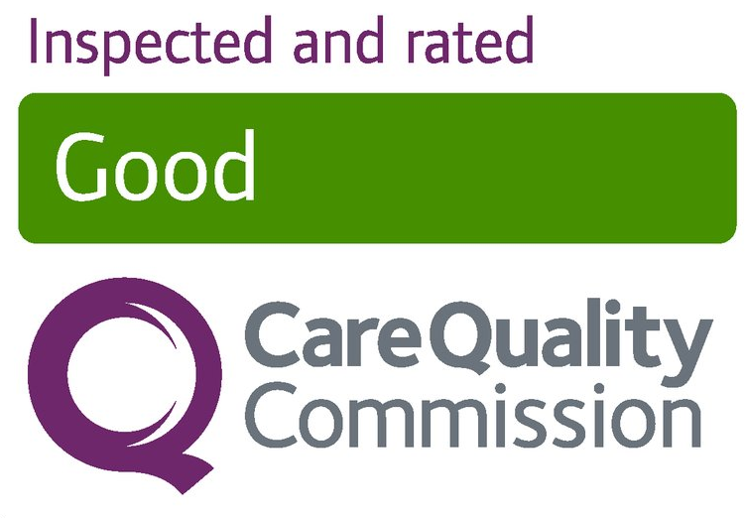
Visitor testing guidance pack Lateral Flow Devices (LFD) in hospices

Compiled using guidance from gov.uk

Visiting Bolton Hospice during the Covid-19 pandemic

Visiting is a central part of Bolton Hospice’s principles. It is crucially important for maintaining health and wellbeing and quality of life for our patients and visitors.
To support visiting, the Department of Health and Social Care is rolling out new rapid tests to hospices to test visitors. This will enable Bolton Hospice to offer regular testing of visitors, to support visits safely with loved ones.
Please read this booklet carefully so that you know what to
expect, as well as the precautions we will ask that you take to keep your loved ones and all our patients and staff safe.
In the event of an outbreak, please note that apart from in exceptional circumstances, visits will not be allowed.
While testing visitors can reduce the risk associated with
visiting, it does not completely remove the risk of infection.
When used alongside robust Infection Prevention and Control (IPC) measures such as Personal Protective Equipment (PPE), testing can support hospices to safely maintain a balance
between infection control and the vital benefits of visiting.
Friends and relatives have a very important role and
responsibility to help Bolton Hospice to keep their loved ones safe. Please think of yourself as part of the team with our staff and volunteers.
By carefully following the steps described in this booklet and requirements laid out, you will be playing your part in helping to protect not just your loved one, but all the people who care for them, from the risk of infection.

What to expect with LFD testing

You will be asked to complete a test prior to your first visit and then twice a week thereafter. If your test is negative, you will be issued with a visitor’s pass which allows you to visit until a documented date, you will then need to take another test to continue visiting.
Testing is really important to help us to identify people who might be carrying Coronavirus but not showing symptoms. Testing may not identify everyone that is currently infectious, but alongside wearing PPE and following other infection
prevent and control measures, testing helps keep the hospice and your loved ones safe.

Do I have to be tested in order for me to visit?
Yes unless you meet the exemption criteria, if you do not want to take a test then you will not be permitted to visit.

Who is exempt from taking a test?
Anyone under the age of 16 and those who have had a
confirmed diagnosis of COVID-19 within the previous 90 days are exempt for taking a test. If you have tested positive, you will need to show the tester your NHS COVID-19 Notification to be able to visit. Without this proof, you will not be allowed to visit and will not be issued with your visitor’s pass.

Preparing for your visit

To keep your loved ones and Bolton Hospice safe, we ask that you follow the below guidelines:

• Stay home if you’re feeling unwell, including if you have a fever, a cough or a change in your sense of taste and smell.

• Follow national guidance outside of your visit, including limiting your contact with other people and wearing a face covering in indoor settings where social distancing may be difficult, and where you will come into contact with people you do not normally meet.

• Observe social distancing with anyone outside of your household or bubble and wash your hands regularly.

Arranging your first visit

If you are accompanying the person on the day of their admission, the test will be offered and completed when you attend the hospice.

For all other visitors, you will not be allowed to visit unless you have been tested and have a negative result or have proven you are exempt from testing.

To book your test appointment, including anyone who
believes they are exempt, please ring reception on 01204 663066 and ask to speak to the Administration Staff between 8.30am and 4pm, Monday to Friday. Appointments are available to pre-book.

The test will take no longer than 10 minutes and the results will be available after 30 minutes. You will not be able to wait in the building for your results and must return to your car.

If you have travelled by public transport then please speak with the tester who will discuss options. If you are exempt, a visitor’s pass will be issued.

What happens at the appointment

At each appointment, you’ll be asked to take a test using a new technology called a Lateral Flow Device (LFD) test.
You’ll be tested before your first visit and twice a week thereafter if you are still visiting the inpatient unit, to check if coronavirus can be detected.

Lateral flow testing should be taken in addition to Personal
Protective Equipment (PPE) and other Infection Prevention and Control (IPC) measures and must not be seen as a way of avoiding their use.

We will ask you to do a throat and nose swab and then will let you know your result in 30 minutes. We will ask you to complete the swabbing yourself, supervised by a
member of staff.

A swab is a small piece of soft, absorbent material on a plastic stick that is used to take a sample from your nose and throat.

The test is very straightforward and you’ll be supported throughout the process by a trained member of staff from the hospice.

Once you have completed your swab, you will be asked to wait in your car for the results. If you are not able to wait, we can telephone you with the results.

Key steps during the test

Please do not arrive more than 5 minutes earlier than your
appointment time.

• Please arrive by yourself (exception of children attending).

• You will be asked to sanitise your hands using alcohol hand gel and asked to put on a surgical face mask.

• Report to reception who will mark you are present on the booking list.

• A staff member will introduce themselves to you and take your temperature.

• You’ll be asked to sign the consent form that you agree to taking the test, sharing your result and holding limited information about you including name and telephone number.

• Hospice staff will assist you to register your result on the government website.

Taking your test:

• A staff member will explain the procedure to you and hand you a packaged swab.

• You will then need to take your own throat and nose swab, supervised by a member of staff. They will walk you through how to swab yourself which will only take about 30 seconds to do.

• You will then place your swab, cotton end down, into the test tube with the testing solution

• The solution is then dropped on to the Lateral flow testing kit and the result will return in 30 minutes

Receiving your result:

• After 30 minutes, the staff member will tell you your result either in person or on the telephone.

• Once you have received your result, a member of the hospice team will assist you to register your information and results on the government website and arrange for the consent form and results to be stored securely for 21 days.

• You will then be asked to make another appointment for your next lateral flow test and be provided with an appointment card.

What your result means

Positive

You will not be able to visit. You will have to take a second test, which is a confirmatory Polymerise Chain Reaction (PCR) test which you will need to arrange yourself either on the
website https://www.gov.uk/get-coronavirus-test or by
calling 119.

You must go home immediately and self-isolate until you receive your result. NHS Test & Trace will text, e-mail, or call you with your result in around 72 hours. If you test positive, NHS Test & Trace may contact you to ask you for your close contacts.

Please inform us of your PCR results and if negative, to arrange another appointment for an LFD test

Invalid or Void
We will ask that you take another LFD test. If the retest comes back as invalid, you will not be allowed to visit, and must book a PCR test.

Negative
Your visit will be able to go ahead, as long as you wear the PPE provided and do not remove it during your visit. You will be issued with a visiting pass and need to book an appointment to continue to visit once this expires.

Visits to the inpatient unit

It is important to recognise that a negative test will provide us with some assurance that you are not carrying the virus.
However, the test is not a complete guarantee.

To keep your loved one and our staff safe, we ask that you please follow the guidelines below during your visit.

• You must show your visitor’s pass every time you visit. You will not be allowed to visit if you do not have it. Visitors’ passes are valid for 3 or 4 days depending on the agreed date of repeat testing and will only be reissued following a negative test or proof of exemption.

• Inside the hospice, you must wear your face mask, apron and gloves at all times.

• You must not remove any item of PPE until you leave (aprons and gloves before you leave the bedroom and mask before you leave the building).

• Each patient has a limit of two nominated visitors, which should remain the same for the duration of the stay in the hospice.

Instructions for putting on PPE

- Perform hand hygiene using soap and water or alcohol hand gel.

- Put on a plastic apron and tie it at the waist.

- Put on a surgical face mask, positioning the blue side face outwards, placing the loops around your ears. With both hands, mould the metal strap over the bridge of your nose.

- Put on plastic gloves.

Removing your PPE safely

Before you leave the patient’s bedroom:
- Remove gloves; grasp the outside of the cuff of the first glove and peel off, holding the glove in the gloved hand,
insert the finger underneath and peel off second glove.

2. Snap or unfasten apron ties at the neck and let the apron fold down on itself. Break ties at waist and fold apron in on itself – do not touch the outside – this will be
contaminated. Discard apron. Wash your hands or apply alcohol hand gel and leave the patient bedroom.

Before you leave reception:
3. Sign out on the iPad.

4. Perform hand hygiene using soap and water or alcohol hand gel or rub & leave the building.

How we register your test kit

Once your result is determined, the staff member will contact you with the results of your test. They will complete the second part of your consent form documenting the result (positive, invalid, negative). Your test kit needs to be registered online which staff will assist you to complete.

https://www.gov.uk/report-covid19-result

The hospice team will advise you if any further steps are required such as if your Lateral flow test is positive.

If you cannot complete the consent form yourself, a member of staff can complete it for you. They will ask you to provide some personal details required in the form.

Details needed for the consent form:
• Full name

Details needed for the online registration:
- Full Name
• Date of birth
• Gender
• Ethnic group
• Home address
• Contact details, including mobile number and e-mail
address
• The barcode or number of the test kit*
• Date and time of test*
• Test result*

*These details will be provided by the staff member on your results card.

Self-swabbing instructions

- Using the mirror to help, look inside your mouth, and find your tonsils at the back of the throat. Your tonsils or where they would be (if they had not been removed) are where you will swab your sample.

- Gently blow your nose into a tissue. Throw the used tissue into the clinical waste bin provided. This is so that you get rid of excess mucus.

- Use hand sanitiser to clean your hands. This is so that you do not contaminate the test kit.

- A member of staff will hand you a packaged swab.
Identify the soft, fabric 5 tip of the swab

The swabbing may feel uncomfortable. Do not insert the swab any deeper if you feel strong resistance or pain. If there is blood or vomit on the swab sample, please alert a member of staff.

- Holding the swab in your hand, open your mouth wide and rub the fabric tip of the swab over both tonsils (or where they would have been) at the back of the throat with good contact at least 3 times (use a mirror to help you do this). Carefully remove the swab stick from the back of your throat.

- Put the same end of the same swab gently into one nostril until you feel a slight resistance (about 2.5cm or 1 inch up your nose). Roll the swab 5 times along the inside of the nostril.

- After collecting the sample hold the swab upright in your hand, do not put it down, and notify a staff member.
Be careful not to touch any surfaces with the swab.

The staff member will instruct you where to place your swab. Use hand sanitiser after handing in your sample. Put your face mask back on and follow the instructions from the staff member.

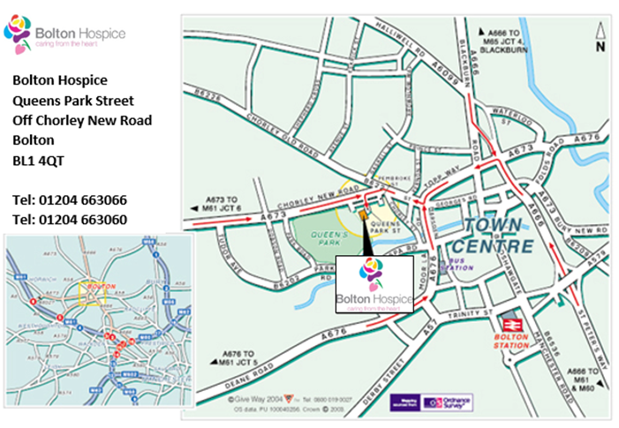
For further information please contact:
Bolton Hospice
Tel: 01204 663 066
Queens Park Street
Off Chorley New Road

