JOB DESCRIPTION
Job Title: | Director of Finance and Corporate Services
Department: | Finance and Corporate Services
Post Holder:
Grade: | TBC
Reports to: | Chief Executive
Accountable to: | Chief Executive and Board of Trustees
Direct reports: | See Below
Organisation Chart:
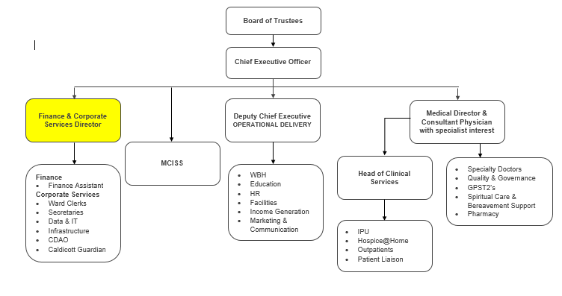

The duties and responsibilities of this post have been assessed as levels of competence required and reflect the skill and knowledge needed to satisfactorily perform the duties of the post.

Job Purpose: | To lead and be responsible for the Finance and Corporate Services functions.  Responsible for providing a full financial management and advisory role to the CEO and Board of Trustees.
Key Working Relationships: | CEO  Treasurer  Senior Leadership Team (Deputy CEO, Medical Director, Head of Clinical Services)
Job Summary: | The post holder will be a member of the Senior Leadership Team (SLT) and will contribute to the Strategic and Operational leadership of the Hospice.  You will manage a very small finance team and be responsible for all aspects of financial control and anti-fraud.  You will have operational and leadership responsibilities of non-clinical services including - Estates/Maintenance; IT; Health and Safety.
Role Responsibilities:
Finance
- Prepare and present the monthly management accounts to the Finance Committee along with supporting explanation and advice
- Reconcile the investment portfolio on a monthly basis and work with the investment managers to report and monitor on investment performance to the Board
- Manage banking arrangements and working capital
- Complete and submit accurate quarterly VAT returns within the required time frames
- Prepare and present the annual budget in collaboration with the budget holders and the CEO to the Finance Committee
- Be responsible for the production of the annual accounts of the hospice and it’s subsidiaries
- Support the Hospices annual audit liaising with and assisting the auditors to ensure completion on time
- Ensure robust financial processions in line with Charity Commission, Companies House, Gambling Commission, HMRC and other regulatory bodies
- Work with the Treasurer, prepare relevant papers and reports to ensure regular oversight of financial performance and transparency of use of charitable funds
- Interpret relevant national and local guidance relating to finance matters. Developing and implementing policies and procedures to enable the achievement of performance objectives and good governance
- Support the hospice in contractual negotiations with subsequent monitoring
- Lead on capital projects and maintenance of hospice property to ensure compliance with current legislation and Health & Safety standards.
- Manage, plan and agree all suitable arrangements with external contractors and hospice staff including Facilities Manager, Porters and Corporate Services Manager. Attend and report to the Building committee.
- Lead on all matters of Health & Safety and support the annual audits. Attend and report to the Health & Safety Committee.
- Lead on Hospice’s IT strategy and IT projects by working closely with the IT Manager and attend the Informatics Committee.
- Arrange and Maintain the Hospice Insurance Policies.
Leadership & Management
- Provide supportive & dynamic leadership to your team and the organisation alongside SLT
- Be highly visible and easily accessible
- Act as an ambassador for Bolton Hospice promoting and upholding our mission and values
- Conduct yourself in a professional and approachable, inclusive manner
- Develop and sustain relationships with partners and stakeholders
- Ensure you and the team provide a quality, value for money service
- Ensure all Policies and Procedures are implemented
- Take responsibility for your own and your teams personal development and training
- Maintain standards of conduct to sustain public confidence

General Responsibilities:
Health and Safety
All employees have a duty to report accidents, complaints, defects in equipment, near misses and untoward incidents, following hospice procedure. Ensure health and safety legislation is complied with at all times, including COSHH and Workplace Assessment.
Confidentiality
All information relating to patients, patients’ families, staff, volunteers, supporters and suppliers gained through your employment with Bolton Hospice is confidential. Disclosure to any unauthorised person is a serious disciplinary offence.
Infection Control
Prevent spread of infection. Comply with policies and procedures for correct disposal of waste, sharps and soiled linen.
Safeguarding Vulnerable People (Children and Adults)
All employees have a responsibility to protect and safeguard vulnerable people (children and adults). They must be aware of child and adult protection procedures and who to contact within the Hospice for further advice. All employees are required to attend safeguarding awareness training and to undertake additional training appropriate to their role.
Disclosure & Barring Service Check
This post is subject to a Disclosure & Barring Service check.
Continuous Personal Development
You are responsible for your own professional development, identifying training and development needs to your line manager and completing all mandatory training as required. You must attend any specialist training and development activities relevant to your role within the hospice.
Valuing Equality and Diversity
All hospice staff should carry out their duties in accordance with the values and principles of our Equality and Diversity strategy. It is the responsibility of all employees to support the hospice commitment to do all we can to ensure we do not exclude, alienate or discriminate in any way and to promote a positive attitude to equality and diversity in adherence to our Equality and Diversity policy.
Living Our Values Everyday
All staff must actively support the vision, aim and values of the hospice, promoting our core values at all times and in all aspects of your work.

This job description is an outline of the main responsibilities. The range of duties and responsibilities outlined above are indicative only and are intended to give a broad flavour of the range and type of duties that will be allocated.
They are subject to modification in the light of changing service demands and the development requirements of the post holder. Therefore, it will be subject to periodic review and amendment.
Employee Name:
Employee Signature: |  | Date:

Manager Name:
Manager Signature: |  | Date:

PERSON SPECIFICATION
Job Title: | Director of Finance and Corporate Services
Department: | Finance and Corporate Services
Grade: | TBC
The person specification sets out the qualifications, experience, skills, knowledge and personal attributes which the post holder requires to perform the job to a satisfactory level.
 | ESSENTIAL | DESIRABLE | METHOD OF ASSESSMENT
QUALIFICATIONS | - 1st level degree or appropriate experience – Qualified Accountant, Member of ICAEW, ACCA or CIPFA |  | Application Form  Certification
EXPERIENCE | - Significant experience of working within financial area  - Experience of managing staff, operationally, including managing performance  - Significant experience of managing staff services at strategic level which has improved outcomes |  | Application Form  Interview
SKILLS | - Ability to deal with staff at all levels of the organisation and with other organisations where issues may be complex or sensitive  - Ability to digest complex information  - Ability to effectively advise non finance managers re: financial procedures  - Ability to deal with staff performance and manage staff appraisal systems  - Ability to use word processing and e-mail packages effectively  - Ability to plan and prioritise won workload and that of others and that financial accounting section to ensure monthly and annual financial timescales and deadlines are met  - Ability to analyse information and determine best course of action to achieve the required objective  - Plan, manage, supervise and organise work and performance review  - Good decision making and prioritisation skills  - Ability to work autonomously and interpret reports/policy regulations guidance e.g. accounting standards |  | Application Form  Interview
KNOWLEDGE | - Specialist knowledge of financial and accounting procedure, including all relevant accounting standards  - Expertise in a range of accounts areas including Annual Accounts, Capital Accounting  - Knowledge and understanding of internal external audit requirements for the proper operation of financial accounts.  - Advance knowledge in use of common software packages  - Knowledge and understanding of Financial Management Information Systems  - Knowledge and understanding of how systems can best be utilised and developed  - Understanding of how best to apply information technology to meet specific tasks.  - Strong IT skills  - Ability to switch between complex tasks and establish priorities when workload demands are high |  | Application Form  Interview
OTHER | - Flexible, able to work out of hours  - Highly enthusiastic and motivated about the work of the Hospice  - Diplomatic  - Car owner/driver  - Enhanced CRB Check |  | Application Form  Interview

