JOB DESCRIPTION

Job Title: | Shop Manager
Department: | Income Generation & Communications
Post Holder: | tbc
Salary: | Admin 2
Reports to: | Retail Operations Manager
Direct reports: | None
Responsible for: | Volunteers

Organisation Chart:
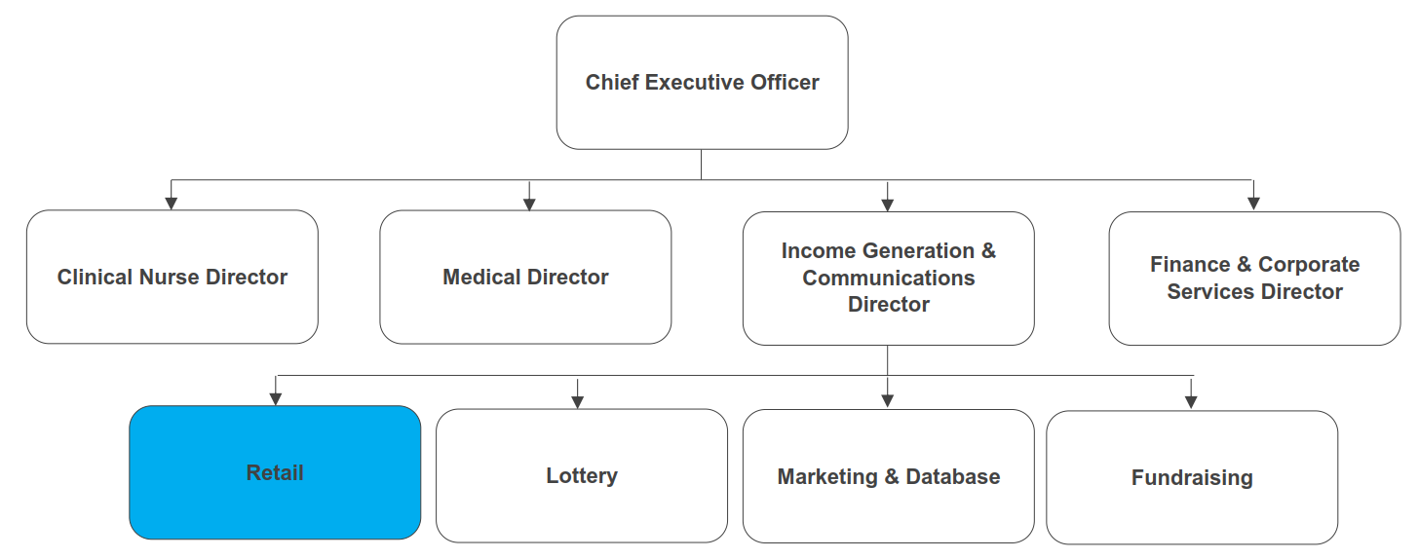
The duties and responsibilities of this post have been assessed as levels of competence required and reflect the skill and knowledge needed to satisfactorily perform the duties of the post.

 | Job Purpose: | To maximise profit for Bolton Hospice through the effective operational management of your assigned charity shop.  Lead and motivate volunteers to deliver an excellent customer experience.
 | Key Working Relationships: | Retail team  Income Generation & Communications team  Volunteers  Donors and Customers

Role Responsibilities:
Shops Operations
- Manage and develop your shop, increasing profitability and maximising income from donated goods.
- Ensure the charity shop is well organised and well run, with effective stock rotation and pricing policies in place to ensure consistency across different volunteer shifts.
- Maintain high standards across all aspects of the charity shop and particularly in relation to customer service, maintenance, volunteer management and visual merchandising.
- Work with the Online Sales Manager, other Shop Managers and shop volunteers to consistently identify donated goods that should be diverted to alternative sales outlets, to maximise income.
- Meet set sales targets and be responsible for the efficiency and profitability of the charity shop.
- Manage gift aid procedures in relation to the charity shop, ensuring that gift aid income is maximised.
- Effectively deal with any customer complaints and act on customer feedback in consultation with your line manager/ Head of Retail to continually develop the charity shops customer experience.
- Utilise appropriate software and paper-based systems to safely and effectively manage volunteer information.
- Ensure appropriate controls are in place to ensure the security of the shop and personal safety are maintained. This includes (but are not limited to) key control, securing of the store when not trading and all hospice security measure are being adhered to.
- Ensure any maintenance issues are promptly reported and/or dealt with.
Leadership & Management
- Effectively recruit, train, supervise and motivate volunteers. Ensure the Bolton Hospice Volunteer Induction is completed in full and any subsequent training is carried out.
- Work to develop Volunteer skills where possible to ensure Volunteers are able to carry out limited job such as pricing, product sorting, processing sales on the till, cashing up and closing/opening of the shop.
- Deliver Health and Safety training to shop volunteers and ensure all policies and procedures in relation to Health & Safety are adhered to in the charity shop.
- Work closely with volunteers to ensure required standards and procedures are consistently maintained.
- Manage volunteer shifts to ensure adequate cover at all times.
- Model the hospice’s values of compassion, respect, professionalism, excellence, inclusivity and collaboration and ensure they are reflected across the charity shop.
Financial & Reporting
- Monitor and report to the Retail Operations Manager on progress against financial and non-financial KPIs, ensuring remedial plans are devised and implemented to address any shortfalls.
- Proactively minimise costs associated with the charity shop.
Teamwork & Collaboration
- Work with the marketing & database team to ensure that the charity shop benefits from appropriate and effective marketing and data management support.
- Work with members of the fundraising and lottery teams to ensure those areas of income generation are effectively promoted in the charity shops and vice versa.
- Attend and contribute to the Retail Team and Income Generation & Communications department meetings as required.
- Work as an integral part of the team, being sensitive to the needs of the whole team and supportive of other team members.
- Provide cover for other members of the Retail Team as required.

Other
- Work within agreed hospice policies, procedures and guidelines.
- Participate in an annual appraisal and undertake training to maintain and develop knowledge and skills as required.
- To always ensure that personnel working in the shop conduct themselves in a professional and appropriate way as ambassadors for Bolton Hospice.
- Any other duties as deemed necessary by your line manager, Head of Retail or Director of Income Generation & Communications.

General Responsibilities:
Health and Safety
All employees have a duty to report and accidents, complaints, defects in equipment, near misses and untoward incidents, following hospice procedure. Ensure health and safety legislation is complied with at all times, including COSHH and Workplace Assessment.
Confidentiality
All information relating to patients, patients’ families, staff, volunteers, supporters and suppliers gained through your employment with Bolton Hospice is confidential. Disclosure to any unauthorised person is a serious disciplinary offence.
Infection Control
Prevent spread of infection. Comply with policies and procedures for correct disposal of waste, sharps and soiled linen.
Safeguarding Vulnerable People (Children and Adults)
All employees have a responsibility to protect and safeguard vulnerable people (children and adults). They must be aware of child and adult protection procedures and who to contact within the Hospice for further advice. All employees are required to attend safeguarding awareness training and to undertake additional training appropriate to their role.
The range of duties and responsibilities outlined above are indicative only and are intended to give a broad flavour of the range and type of duties that will be allocated. They are subject to modification in the light of changing service demands and the development requirements of the post holder.
Disclosure & Barring Service Check
This post is subject to a Disclosure & Barring Service check.
Continuous Personal Development
You are responsible for your own professional development, identifying training and development needs to your line manager and completing all mandatory training as required. You must attend any specialist training and development activities relevant to your role within the hospice.
Valuing Equality and Diversity
All hospice staff should carry out their duties in accordance with the values and principles of our Equality and Diversity strategy. It is the responsibility of all employees to support the hospice commitment to do all we can to ensure we do not exclude, alienate or discriminate in any way and to promote a positive attitude to equality and diversity in adherence to our Equality and Diversity policy.
Living Our Values Everyday
All staff must actively support the vision, aim and values of the hospice, promoting our core values at all times and in all aspects of your work.

The range of duties and responsibilities outlined above are indicative only and are intended to give a broad flavour of the range and type of duties that will be allocated. They are subject to modification in the light of changing service demands and the development requirements of the post holder.
This job description is an outline of the main responsibilities. It will be subject to periodic review and amendment.
Employee Name:
Employee Signature: |  | Date:

Manager Name:
Manager Signature: |  | Date:

PERSON SPECIFICATION

Job Title: | Shop Manager
Department: | Income Generation & Communications
Salary: | Admin 2

The person specification sets out the qualifications, experience, skills, knowledge and personal attributes which the post holder requires to perform the job to a satisfactory level.

 | ESSENTIAL | DESIRABLE | METHOD OF ASSESSMENT
QUALIFICATIONS | A good standard of numeracy and literacy. |  | Application Form
EXPERIENCE | Experience working within a retail environment.  Experience of working with volunteers.  Experience of dealing with the public. | Experience of working in the charity sector.  Experience of recruiting / managing volunteers.  Experience of working to and achieving financial targets. | Application Form  Interview
SKILLS | Excellent customer service skills.  Excellent organisational skills.  Excellent communication & interpersonal skills - able to work alongside volunteers from all walks of life with varying learning abilities. | Influencing skills. | Application Form  Interview
KNOWLEDGE | Computer literate - Microsoft Office and databases.  Knowledge of Health & Safety legislation in relation to retail. | Knowledge of retail gift aid administration.  Knowledge of legislation and regulations in relation to the sale of second-hand goods. | Application Form  Interview
PERSONAL ATTRIBUTES | Self-motivated and able to use initiative.  Able to plan, manage and prioritise own workload.  Able to work under pressure.  Strong teamwork ethic.  Willingness to work flexibly to fulfil the requirements of the post.  A commitment to the vision and values of Bolton Hospice.  A full driving licence and access to a vehicle insured for business use subject to the Equality Act 2010. | Commitment to continuous professional development. | Application Form  Interview

